**RESPIRATORY SYSTEM**

**INTRODUCTION**

The respiratory system is the network of organs and tissues that helps to breathe. It includes our airways, lungs and blood vessels. The muscles that power our lungs are also part of the respiratory system. These parts work together to move oxygen throughout the body and clean out waste gases like carbon dioxide.

All physical and chemical reactions in which atmospheric air oxidizes food in the body cells resulting in production of energy and liberation of Co2 are included in respiration.

Process of exchange of oxygen from the atmosphere with carbon dioxide produced by the cells is called RESPIRATION.

It is a catabolic process.

The respiratory system works with the circulatory system to provide this oxygen and to remove the waste products of metabolism.

It also helps to regulate pH of the blood.

Respiration is the sequence of events that results in the exchange of oxygen and carbon dioxide between the atmosphere and the body cells.

Every 3 to 5 seconds, nerve impulses stimulate the breathing process, or ventilation, which moves air through a series of passages into and out of the lungs.

**TYPES OF RESPIRATION**:

Aerobic and anaerobic respiration

**1)Anaerobic respiration:**

It occurs when nutrients are incompletely oxidized without using O2. It is a low energy yielding process.

**2)Aerobic respiration:**

Cells utilize O2 for completely oxidizing the nutrients. O2 is used either from atmospheric air or from water. It involves

**a) External respiration:**

It is the exchange of O2 present in surrounding gaseous or liquid medium and in blood through a liquid medium by diffusion across the body surface.

**b) Internal respiration:**

It is the exchange of O2 present in blood and CO2 in the body cells through tissue fluid at cellular level.

**c) Cellular respiration:**

It is the utilization of O2 by cells for energy production and resultant release of CO2.

**IMPORTANCE OF RESPIRATORY SYSTEM:**

The cells in our bodies need oxygen to stay alive. Carbon dioxide is made in our bodies as cells do their jobs. The lungs and respiratory system allow oxygen in the air to be taken into the body, while also letting the body get rid of carbon dioxide in the air breathed out.

**ANATOMY OF RESPIRATORY SYSTEM**

The respiratory system, functionally, can be separated in two zones; conducting zones (nose to bronchioles) form a path for conduction of the inhaled gases and respiratory zone (alveolar duct to alveoli) where the gas exchange takes place. Anatomically, respiratory tract is divided into upper (organ outside thorax - nose, pharynx and larynx) and lower respiratory tract (organ within thorax - trachea, bronchi, bronchioles, alveolar duct and alveoli).

The discussion is mainly concentrated on the lower respiratory tract and the related physiology. Nose and nasal cavity are divided into two halves by the nasal septum. The lateral wall of the nose consists of three turbinates or conchae (superior, middle and inferior). The passage inferior to inferior turbinate is preferred passage for nasotracheal intubation.

The respiratory system consists of external nostrils, nasal chambers, pharynx, larynx, trachea, bronchi, bronchioles and lungs.

Nasal passage is functionally divided into 3 regions:

1. **Vestibular region:** Skin, hair, sebaceous glands are present.
2. **Respiratory region:** It is lined by pseudo stratified columnar ciliated glandular epithelium. It has 3 twisted bony plates called CONCHAE.
3. **Olfactory region:** Neuro sensory epithelium

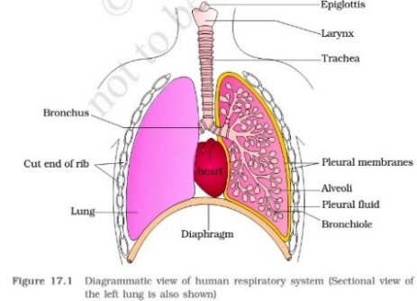

**PHARYNX:**

The pharynx is a tube-like passage that connects the posterior nasal and oral cavities to the larynx and esophagus. It is divided into nasopharynx, oropharynx and laryngopharynx. Increase in soft tissue within bony enclosure of pharynx or decrease in bony enclosure size would result in anatomical imbalance and cause limitation of space available for airways.

There are three narrowest portions of pharynx; passage posterior to the soft palate (retro palatal space), passage posterior to the tongue (retroglossal space) and passage posterior to epiglottis (retropalatal space). There is significant reduction of these spaces with sedation and anesthesia which would lead to upper airway obstruction.

**The pharynx includes:**

1. **Nasopharynx:** The top part of the throat connects to the nasal cavities and lets air pass through.
2. **Oropharynx:** The middle part of the throat connects to the oral cavity. It allows air food and fluid to pass through.
3. **Laryngopharynx:** The bottom part of the throat is near the larynx. It regulates the passage of air to the lungs and food and fluid to the esophagus.

**The pharynx also contains:**

1. **Tonsils:** There are three sets of tonsils. They are located at the back of the throat and base of the tongue. Tonsils are the body’s first defense against infection.
2. **Auditory tubes:** These two tubes connect the ears to the throat. They equalize pressure and help drain fluid.

## ANATOMICAL FACTORS WHICH COMPROMISE PHARYNGEAL PATENCY

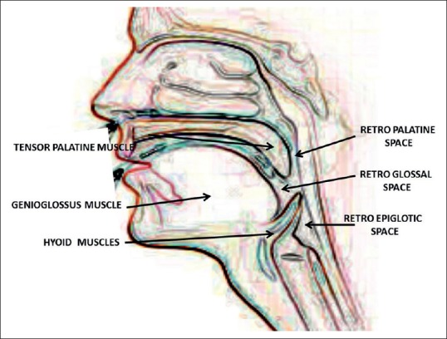

**LARYNX:**

It is a cartilaginous box which helps in sound production and hence called SOUND BOX. In larynx 2 pairs of vocal cords are present for sound production.

1. **Anterior pair:** These are called false vocal cords. These are composed of mucus membranes. They are pink in color and they do not help in phonation. They provide moisture to true vocal cords.
2. **Posterior pair:** These are true vocal cords. They are composed of sheet of yellow fibrous connective tissue and produce sound.

In males the vocal cords are thicker, longer, and produce low pitch voice, where as in women and children and vocal cords are usually short and produce high pitch voice.

**Larynx is supported by 9 cartilages**

1. **Thyroid cartilage:** Single, largest, C-shaped, dorsally incomplete, hyaline cartilage.
2. **Cricoid cartilage:** Single, signet ring shaped, below thyroid cartilage, hyaline cartilage.
3. **Epiglottis:** Single, flap like, elastic cartilage
4. **Arytenoid cartilage:** One pair, pyramid shaped hyaline cartilage.
5. **Cartilage of Santorini:** One pair, node like cartilages, present at the end of arytenoid cartilages.
6. **Cuneiform cartilage:** One pair, present on lateral cartilage.

**Adam’s apple:** The mid ventral part of thyroid cartilage forms the laryngeal prominence called Adam’s apple.

**TRACHEA:**

It is a 10-12 cm long and 2-5 cm in diameter. It is a straight tube extending up to the mid thoracic cavity, which divides at the level of 5th thoracic vertebra into a right and left primary bronchi. Each primary bronchus undergoes repeated divisions to form the secondary and tertiary bronchi and bronchioles ending up in very thin terminal bronchioles. The trachea, primary, secondary and tertiary bronchi and initial bronchioles are supported by ‘C’ shaped cartilaginous rings, which are incomplete on dorsal side and prevent from collapsing.

Each terminal bronchiole gives rise to number of very thin, irregular walled and vascularized bag like structures called alveoli. Branches of primary bronchus up to Terminal bronchioles makes **bronchial tree.**

## TRACHEOBRONCHIAL TREE

It is a complex system that transports gases from the trachea down to the acini, the gas exchange units of the lung. It is partitioned into 23 generations of dichotomous branching, extending from trachea (generation 0) to the last order of terminal bronchioles (generation 23). At each generation, each airway is being divided into two smaller daughter airways.

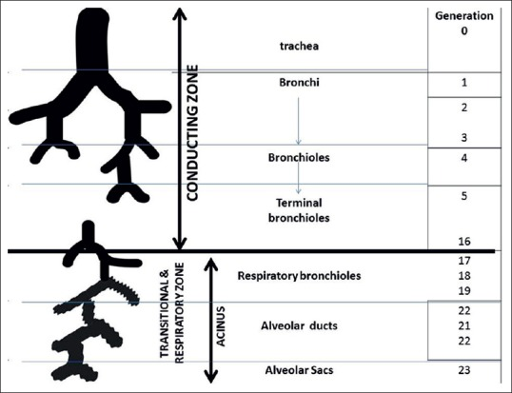

**TRACHEOBRONCHIAL TREE**

From the trachea to the terminal bronchioles (generation 15–16), the airways are purely conducting pipes. Since no gas exchanges take place in this region, the volume in these pipes is called as the dead space volume (average 150 ml). The terminal bronchioles (generation 16) divide into respiratory bronchioles or transitional bronchioles (generations 17–19) as they have occasional alveoli at the walls. These respiratory bronchioles further divide into alveolar ducts (generations 20–22) which are completely lined with alveoli.

This region is known as acinus (generations 16–23). The acinus is comprised of respiratory airways and forms functional tissues (gas exchange units) of lung. The alveolar ducts are small tubes supported by a rich matrix of elastic and collagen fibers. The distal ends of alveolar ducts open into the alveolar sac which is made up by alveoli. **Respiratory tree** includes respiratory bronchioles, alveolar ducts, atria, alveolar sac and alveoli.

## TRACHEA AND RIGHT/LEFT MAIN BRONCHUS

The trachea is a hollow conduit for gases and bronchial secretions. It extends from the level of C6 (cricoid cartilage) to the carina, approximately located at the level of T4-T5. In adults, its length is approximately 11–13 cm, with 2–4 cm being extra-thoracic. The trachea has 16 to 22 horseshoe bands (c-shaped) of cartilages. The posterior tracheal wall lacks cartilage and is supported by the trachealis muscle. Depending on the level of inspiration, the posterior wall of the trachea becomes flat, convex or slightly concave. The posterior wall of the trachea either flattens or bows slightly forward during expiration. In normal subjects, there is up to 35% reduction in antero-posterior tracheal lumen in forced expiration, whereas the transverse diameter decreases only by 13%. The trachea is generally midline in position, often displaced slightly to the right and posteriorly as it approaches carina. The angle of the tracheal bifurcation is called as the carinal/subcarinal angle, which is measured commonly as 73° (35–90°). The carinal angle is wider in individuals with an enlarged left atrium, in females and obese patients.

The trachea divides at carina into the right and left main bronchus. The distance of the carina from the teeth varies markedly with change in neck position from flexion to extension (tracheal length variation is ± 2 cm), body position and position of diaphragm. This explains the change in position of endotracheal tube during change in position of patient or flexion – extension of neck.

 The right main stem bronchus divides into (secondary bronchi) right upper lobe bronchus and bronchus intermedius which further divides into right middle and lower lobe bronchus. The left bronchus passes anterolaterally at a greater angle from the vertical axis than the right bronchus. The left main stem bronchus divides into (secondary bronchi) the left upper and lower lobe bronchi.

## BRONCHO-PULMONARY SEGMENT

Broncho-pulmonary segment may be defined as an area of distribution of any bronchus. Each lobar bronchi divides into segmental bronchi (tertiary bronchi), which supply the broncho-pulmonary segment of each lobe. Technically, there are ten broncho-pulmonary segments in each lung, but in left lung, some of these segment’s fuse and there are as few as eight broncho-pulmonary segments. The bronchi continue to divide into smaller and smaller bronchi up to 23 generations of divisions from main bronchus. As bronchi become smaller, their structure changes:

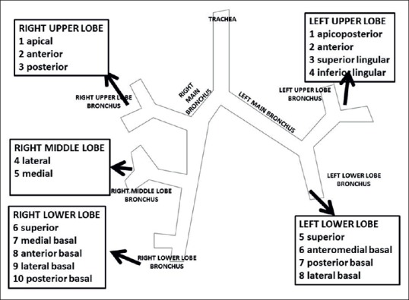

1. Cartilaginous ring becomes irregular and then disappear. When bronchi lose all cartilaginous support, the airway is then referred as bronchioles
2. The epithelium changes from pseudostratified columnar to columnar to cuboidal in the terminal bronchioles
3. There are no cilia and mucous producing cells in bronchioles
4. The amount of smooth muscle in the tube wall increases as the airway becomes smaller.

## DIMENSIONS OF TRACHEOBRONCHIAL TREE

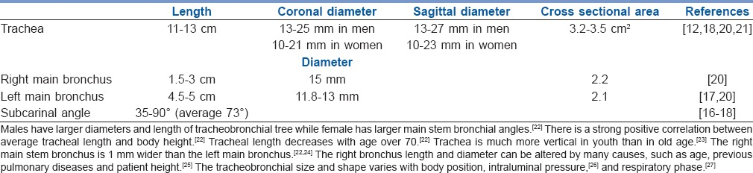

Ascertaining the parameters of tracheobronchial tree such as length, diameters and angulations helps optimizing procedures such as intubation, lung isolation techniques and jet ventilation during interventional endoscopic surgeries of trachea or bronchi.

### **Tracheobronchial anatomical variations**

Tracheobronchial tree exhibits a wide range of variations and its prevalence is 4%. The most common main bronchus anomalies are the tracheal bronchus and the accessory cardiac bronchus. Knowledge of tracheobronchial variants is important for clinical aspect in pre-operative evaluation in view of intubation, lung isolation techniques and other endo-bronchial procedures.

### **Tracheobronchial anatomical variations**

This is a bronchus usually originating from the right side of the trachea above the carina and within 2–6 cm from it. Right tracheal bronchus has a prevalence of 0.1–2% and left bronchus has a prevalence of 0.3–1%. The tracheal bronchus may cause complications such as atelectasis or pneumothorax in the cases of obstruction to its entrance or tube entering into it during intubation.

#### **ACESSORY CARDIAC BRONCHUS**

It is a congenital, short and thin bronchus towards pericardium originating either from right bronchus or intermediate bronchus. Its prevalence is 0.08%. It is associated with recurrent infections in few cases.

**LUNGS:**

A pair of lungs are present in the thoracic cavity. In human beings the right lung id divided into 3 lobes and left lung into 2 lobes. Lungs are covered by double layered pleura with pleural fluid, it reduces the friction on the lung surface. Outer membrane is the Parietal pleura and inner membrane is Visceral pleura.

Both membranes derived from mesoderm. In between both membranes a very narrow cavity called Pleural cavity is present. In thus cavity a very thin layer of pleural fluid is present that reduces the friction on the lung surface. The left lung is smaller than the right lung as it has a cavity known as Cardiac notch, where the heart is located.

The respiratory system has conducting part and exchange part.

The conducting part starts with external nostrils and ends with terminal bronchioles. Alveoli and their ducts form the exchange part. Exchange part is the site of actual diffusion oxygen and carbon dioxide between blood and atmospheric air. Lungs are situated in the thoracic chamber which is an air tight chamber.

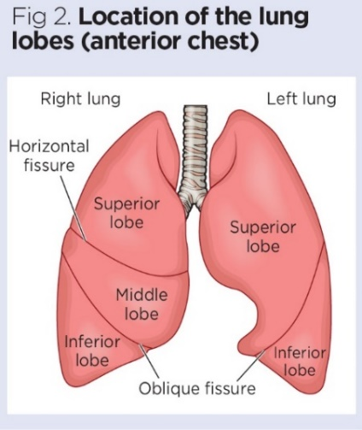

**ALVEOLI:**

Structural and functional unit of lungs is called alveoli. Approximately 300m alveoli are present in both the lungs. Alveoli are very thin irregular walled and vascularized bag like structures. Wall of alveoli consist of 2 layers, outer layer composed of yellow fibrous connective tissue inner layer composed of simple squamous epithelium. It is richly supplied with blood capillaries.

These blood capillaries come from pulmonary artery. Pulmonary artery divides into blood capillaries after reaching to lungs. All capillaries combine to form pulmonary vein at the end. Pulmonary veins carry pure blood to the left atrium of heart.

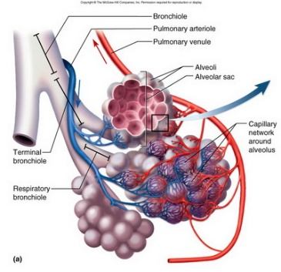

**MECHANISM OF BREATHING:**

Breathing involves 2 stages: inspiration and expiration.

**INSPIRATION:** Intake of atmospheric air into lungs is called inspiration. It is an active process.

**MUSCLE MOVEMENT IN INSPIRATION:**

Contraction of muscles of diaphragm and external inter coastal muscles which extend in between ribs. The contraction of diaphragm – phrenic muscles increase the volume of thoracic chamber in antero-posterior axis.

Contraction of external inter coastal muscles lifts up ribs and sternum causing an increase in the volume of thoracic chamber in the dorsa-ventral axis. The overall increase in thoracic volume causes similar increase in pulmonary volume. An increase in pulmonary volume decreases intra-pulmonary pressure to less than that of atmospheric which forces air from outside to move into lungs.

**EXPIRATION:**

Release of alveolar air to the exterior is called expiration. It is passive process. Relaxation of diaphragm and external inter-coastal muscles returns diaphragm and sternum to their normal position, reduces thoracic volume and thereby pulmonary volume.

This leads to an increase in inter-pulmonary pressure to slightly above that of the atmospheric pressure, causing the expulsion of air from the lungs.

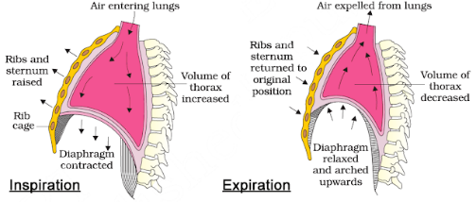

# **Case Study: 60-Year-Old Female Presenting with Shortness of Breath**

## Case Presentation

The patient is a 60-year-old white female presenting to the emergency department with acute onset shortness of breath.  Symptoms began approximately 2 days before and had progressively worsened with no associated, aggravating, or relieving factors noted. She had similar symptoms approximately 1 year ago with an acute, chronic obstructive pulmonary disease (COPD) exacerbation requiring hospitalization. She uses BiPAP ventilatory support at night when sleeping and has requested to use this in the emergency department due to shortness of breath and wanting to sleep. She denies fever, chills, cough, wheezing, sputum production, chest pain, palpitations, pressure, abdominal pain, abdominal distension, nausea, vomiting, and diarrhea.

She reports difficulty breathing at rest, forgetfulness, mild fatigue, feeling chilled, requiring blankets, increased urinary frequency, incontinence, and swelling in her bilateral lower extremities that are new-onset and worsening. Subsequently, she has not ambulated from bed for several days except to use the restroom due to feeling weak, fatigued, and short of breath.

There are no known ill contacts at home. Her family history includes significant heart disease and prostate malignancy in her father. Social history is positive for smoking tobacco use at 30 pack years. She quit smoking 2 years ago due to increasing shortness of breath. She denies all alcohol and illegal drug use. There are no known foods, drugs, or environmental allergies.

Past medical history is significant for coronary artery disease, myocardial infarction, COPD, hypertension, hyperlipidemia, hypothyroidism, diabetes mellitus, peripheral vascular disease, tobacco usage, and obesity.  Past surgical history is significant for an appendectomy, cardiac catheterization with stent placement, hysterectomy, and nephrectomy.

Her current medications include fluticasone-vilanterol 100-25 mcg inhaled daily, hydralazine 50 mg by mouth, 3 times per day, hydrochlorothiazide 25 mg by mouth daily, albuterol-ipratropium inhaled every 4 hours PRN, levothyroxine 175 mcg by mouth daily, metformin 500 mg by mouth twice per day, nebivolol 5 mg by mouth daily, aspirin 81 mg by mouth daily, vitamin D3 1000 units by mouth daily, clopidogrel 75 mg by mouth daily, isosorbide mononitrate 60 mg by mouth daily, and rosuvastatin 40 mg by mouth daily.

**Physical Exam**

Initial physical exam reveals temperature 97.3 F, heart rate 74 bpm, respiratory rate 24, BP 104/54, HT 160 cm, WT 100 kg, BMI 39.1, and O2 saturation 90% on room air.

**Constitutional:** Extremely obese, acutely ill-appearing female. Well-developed and well-nourished with BiPAP in place. Lying on a hospital stretcher under 3 blankets.

**HEENT:**

1. Head: Normocephalic and atraumatic
2. Mouth: Moist mucous membranes
3. Macroglossia
4. Eyes: Conjunctiva and EOM are normal. Pupils are equal, round, and reactive to light. No scleral icterus. Bilateral periorbital edema present.
5. Neck: Neck supple. No JVD present. No masses or surgical scarring.
6. Throat: Patent and moist

**Cardiovascular:** Normal rate, regular rhythm, and normal heart sound with no murmur. 2+ pitting edema bilateral lower extremities and strong pulses in all four extremities.

**Pulmonary/Chest:** No respiratory status distress at this time, tachypnea present, (+) wheezing noted, bilateral rhonchi, decreased air movement bilaterally. The patient was barely able to finish a full sentence due to shortness of breath.

**Abdominal:** Soft. Obese. Bowel sounds are normal. No distension and no tenderness

**Skin:**Skin is very dry

**Neurologic:** Alert, awake, able to protect her airway. Moving all extremities. No sensation losses

## Initial Evaluation

Initial evaluation to elucidate the source of dyspnea was performed and included CBC to establish if an infectious or anemic source was present, CMP to review electrolyte balance and review renal function, and arterial blood gas to determine the PO2 for hypoxia and any major acid-base derangement, creatinine kinase and troponin I to evaluate the presence of myocardial infarct or rhabdomyolysis, brain natriuretic peptide, ECG, and chest x-ray. Considering that it is winter and influenza is endemic in the community, a rapid influenza assay was obtained as well.

**CBC**

Largely unremarkable and non-contributory to establish a diagnosis.

**CMP**

Showed creatinine elevation above baseline from 1.08 base to 1.81, indicating possible acute injury. EGFR at 28 is consistent with chronic renal disease. Calcium was elevated to 10.2. However, when corrected for albumin, this corrected to 9.8 mg/dL. Mild transaminitis is present as seen in alkaline phosphatase, AST, and ALT measurements which could be due to liver congestion from volume overload.

Initial arterial blood gas with pH 7.491, PCO2 27.6, PO2 53.6, HCO3 20.6, and oxygen saturation 90% on room air, indicating respiratory alkalosis with hypoxic respiratory features. Creatinine kinase was elevated along with serial elevated troponin I studies. In the setting of her known chronic renal failure and acute injury indicated by the above creatinine value, a differential of rhabdomyolysis is determined.

Influenza A and B: Negative

**ECG**

Normal sinus rhythm with non-specific ST changes in inferior leads. Decreased voltage in leads I, III, aVR, aVL, aVF.

**Chest X-ray**

*Findings:*

Bibasilar airspace disease that may represent alveolar edema. Cardiomegaly noted. Prominent interstitial markings were noted. Small bilateral pleural effusions

*Radiologist Impression:*

Radiographic changes of congestive failure with bilateral pleural effusions greater on the left compared to the right.

**Differential Diagnosis**

1. Acute on chronic COPD exacerbation
2. Acute on chronic renal failure
3. Bacterial pneumonia
4. Congestive heart failure
5. NSTEMI
6. Pericardial effusion
7. Hypothyroidism
8. Influenza pneumonia
9. Pulmonary edema
10. Pulmonary embolism

**Confirmatory Evaluation**

On the second day of the admission patient’s shortness of breath was not improved, and she was more confused with difficulty arousing on conversation and examination. To further elucidate the etiology of her shortness of breath and confusion, the patient's husband provided further history. He revealed that she is poorly compliant with taking her medications. He reports that she “doesn’t see the need to take so many pills.”

Testing was performed to include TSH, free T4, BNP, repeated arterial blood gas, CT scan of the chest, and echocardiogram. TSH and free T4 evaluate hypothyroidism. BNP evaluates fluid load status and possible congestive heart failure. CT scan of the chest will look for anatomical abnormalities.

An echocardiogram is used to evaluate left ventricular ejection fraction, right ventricular function, pulmonary artery pressure, valvular function, pericardial effusion, and any hypokinetic area.

TSH: 112.717 (H)

Free T4: 0.56 (L)

TSH and Free T4 values indicate severe primary hypothyroidism.

## Diagnosis

1. Myxedema coma or severe hypothyroidism
2. Pericardial effusion secondary to myxedema coma
3. COPD exacerbation
4. Acute on chronic hypoxic respiratory failure
5. Acute respiratory alkalosis
6. Bilateral community-acquired pneumonia
7. Small bilateral pleural effusions
8. Acute mild rhabdomyolysis
9. Acute chronic, stage IV, renal failure
10. Elevated troponin I levels, likely secondary to Renal failure
11. Diabetes mellitus type 2, non-insulin-dependent
12. Extreme obesity
13. Hepatic dysfunction

## Management

The patient was extremely ill and rapidly decompensating with multisystem organ failure, including respiratory failure, altered mental status, acute on chronic renal failure, and cardiac dysfunction. The primary concerns for the stability of the patient revolved around respiratory failure coupled with altered mental status. In the intensive care unit (ICU), she rapidly began to fail BiPAP therapy. Subsequently, the patient was emergently intubated in the ICU.  A systemic review of therapies and hospital course is as follows:

**Endocrine**

Considering the primary diagnosis of myxedema coma, early supplementation with thyroid hormone is essential.

Healthcare providers followed the American Thyroid Association recommendations, which recommend giving combined T3 and T4 supplementation; however, T4 alone may also be used. T3 therapy is given as a bolus of 5 to 20 micrograms intravenously and continued at 2.5 to 10 micrograms every 8 hours. An intravenous loading dose of 300 to 600 micrograms of T4 is followed by a daily intravenous dose of 50 to 100 micrograms. Repeated monitoring of TSH and T4 should be performed every 1 to 2 days to evaluate the effect and to titrate the dose of medication. The goal is to improve mental function. Until coexistent adrenal insufficiency is ruled out using a random serum cortisol measurement, 50 to 100 mg every 8 hours of hydrocortisone should be administered. In this case, clinicians used hydrocortisone 100 mg IV every 8 hours. Dexamethasone 2 to 4 mg every 12 hours is an alternative therapy.

**Neurologic**

The patient’s mental status rapidly worsened despite therapy. In the setting of her hypothyroidism history, this may be myxedema coma or due to the involvement of another organ system. The thyroid supplementation medications and hydrocortisone were continued. A CT head without contrast was normal.

**Respiratory**

For worsening metabolic acidosis and airway protection, the patient was emergently intubated. Her airway was deemed high risk due to having a large tongue, short neck, and extreme obesity. As the patient’s heart was preload dependent secondary to pericardial effusion, a 1-liter normal saline bolus was started. Norepinephrine was started at a low dose for vasopressor support, and ketamine with low dose Propofol was used for sedation. Ketamine is a sympathomimetic medication and usually does not cause hypotension as all other sedatives do. The patient was ventilated with AC mode of ventilation, tidal volume of 6 ml/kg ideal body weight, flow 70, initial fio2 100 %, rate 26 per minute (to compensate for metabolic acidosis), PEEP of 8

**Gastrointestinal**

Nasogastric tube feedings were started on the patient after intubation. She tolerated feedings well. AST and ALT were mildly elevated, which was thought to be due to hypothyroidism, and as the TSH and free T4 improved, her AST and ALT improved. Eventually, these values became normal once her TSH level was close to 50.

**Cardiovascular**

She was determined to be hemodynamically stable with a pericardial effusion. This patient’s cardiac dysfunction was diastolic in nature, as suggested by an ejection fraction of 66% to 70%. The finding of posterior pericardial effusion further supported this conclusion. The posterior nature of this effusion was not amenable to pericardiocentesis. As such, this patient was preload dependent and showed signs of hypotension. The need for crystalloid fluid resuscitation was balanced against the impact increased intravascular volume would have on congestive heart failure and fluid overload status. Thyroid hormone replacement as above should improve hypotension. However, vasopressor agents may be used to maintain vital organ perfusion targeting a mean arterial pressure of greater than 65 mm Hg as needed. BP improved after fluid bolus, and eventually, the norepinephrine was stopped. Serial echocardiograms were obtained to ensure that the patient did not develop tamponade physiology. Total CK was elevated, which was likely due to Hypothyroidism compounded with chronic renal disease.

**Infectious Disease**

Blood cultures, urine analysis, and sputum cultures were obtained. The patient's white blood cell count was normal. This is likely secondary to her being immunocompromised due to hypothyroidism and diabetes. In part, the pulmonary findings of diffuse edema and bilateral pleural effusions can be explained by cardiac dysfunction. Thoracentesis of pleural fluid was attempted, and the fluid was analyzed for cytology and gram staining to rule out infectious or malignant causes as both a therapeutic and diagnostic measure. Until these results return, broad-spectrum antibiotics are indicated and may be discontinued once the infection is ruled out completely.

**Renal**

Her baseline creatinine was found to be close to 1.08 in prior medical records. She presented with a creatinine of 1.8 in the emergency department. Since hypothyroidism causes fluid retention in part because thyroid hormone encourages excretion of free water and partly due to decreased lymphatic function in returning fluid to vascular circulation.  Aggressive diuresis was attempted. As a result, her creatinine increased initially but improved on repeated evaluation, and the patient had a new baseline creatinine of 1.6. Overall, she had a net change in the fluid status of 10 liters negative by her ten days of admission in the ICU.

**Discussion**

Despite the name myxedema coma, most patients will not present in a coma status. This illness is at its core a severe hypothyroidism crisis that leads to systemic multiorgan failure. Thyroid hormones T3, and to a lesser extent, T4 act directly on a cellular level to upregulate all metabolic processes in the body. Therefore, deficiency of this hormone is characterized by systemic decreased metabolism and decreased glucose utilization along with increased production and storage of osmotically active mucopolysaccharide protein oxblood cultures, urine analysis, and sputum cultures were obtained. The patient's white blood cell count was normal. This is likely secondary to her being immunocompromised due to hypothyroidism.

Her baseline creatinine was found to be close to 1.08 in prior medical records. She presented with a creatinine of 1.8 in the emergency department. Since hypothyroidism causes fluid retention in part because thyroid hormone encourages excretion of free water and partly due to decreased lymphatic function in returning fluid to vascular circulation.  Aggressive diuresis was attempted. As a result, her creatinine increased initially but improved on repeated evaluation, and the patient had a new baseline creatinine of 1.6. Overall, she had a net change in the fluid status of 10 liters negative by her ten days of admission in the ICU.

In part, the pulmonary findings of diffuse edema and bilateral pleural effusions can be explained by cardiac dysfunction. Thoracentesis of pleural fluid was attempted, and the fluid was analyzed for cytology and gram staining to rule out infectious or malignant causes as both a therapeutic and diagnostic measure.

Until these results return, broad-spectrum antibiotics are indicated and may be discontinued once the infection is ruled out completely. plexus into peripheral tissues resulting in diffuse edema and swelling of tissue.

Myxedema coma is an illness that occurs primarily in females at a rate of 4:1 compared to men. It typically impacts the elderly at the age of greater than 60 years old, and approximately 90% of cases occur during the winter months. Myxedema coma is the product of longstanding unidentified or undertreated hypothyroidism of any etiology.

Thyroid hormone is necessary throughout the body and acts as a regulatory hormone that affects many organ systems. In cardiac tissues, myxedema coma manifests as decreased contractility with subsequent reduction in stroke volume and overall cardiac output.  Bradycardia and hypotension are typically present also. Pericardial effusions occur due to the accumulation of mucopolysaccharides in the pericardial sac, which leads to worsened cardiac function and congestive heart failure from diastolic dysfunction.

Capillary permeability is also increased throughout the body leading to worsened edema. Electrocardiogram findings may include bradycardia and low-voltage, non-specific ST waveform changes with possible inverted T waves.

Neurologic tissues are impacted in myxedema coma leading to the pathognomonic altered mental status resulting from hypoxia and decreased cerebral blood flow secondary to cardiac dysfunction as above. Additionally, hypothyroidism leads to decreased glucose uptake and utilization in neurological tissue, thus worsening cognitive function.

The pulmonary system typically manifests this disease process through hypoventilation secondary to the central nervous system (CNS) depression of the respiratory drive with blunting of the response to hypoxia and hypercapnia. Additionally, metabolic dysfunction in the muscles of respiration leads to respiratory fatigue and failure, macroglossia from mucopolysaccharide driven edema of the tongue leads to mechanical obstruction of the airway, and obesity hypoventilation syndrome with the decreased respiratory drive as most hypothyroid patients suffer from obesity.

Renal manifestations include decreased glomerular filtration rate from the reduced cardiac output and increased systemic vascular resistance coupled with acute rhabdomyolysis led to acute kidney injury. In the case of our patient above who has a pre-existing renal disease status post-nephrectomy, this is further worsened.  The net effect is worsened fluid overload status compounding the cardiac dysfunction and edema.

The gastrointestinal tract is marked by mucopolysaccharide-driven edema as well leading to malabsorption of nutrients, gastric ileus, and decreased peristalsis. Ascites is common because of increased capillary permeability in the intestines coupled with coexistent congestive heart failure and congestive hepatic failure. Coagulopathies are common to occur as a result of this hepatic dysfunction.

***Evaluation:***

The diagnosis of myxedema coma, as with all other diseases, is heavily reliant on the history and physical exam. A past medical history including hypothyroidism is highly significant whenever decreased mental status or coma is identified.

In the absence of identified hypothyroidism, myxedema coma is a diagnosis of exclusion when all other sources of coma have been ruled out. If myxedema coma is suspected, evaluation of thyroid-stimulating hormone (TSH), free thyroxine (T4), and serum cortisol is warranted.

T4 will be extremely low. TSH is variable depending on the etiology of hypothyroidism, with a high TSH indicating primary hypothyroidism and a low or normal TSH indicating secondary etiologies. Cortisol may be low indicating adrenal insufficiency because of hypothyroidism.

***Prognosis:***

Myxedema coma is a medical emergency. With proper and rapid diagnosis and initiation of therapy, the mortality rate is still as high as 25% to 50%. The most common cause of death is due to respiratory failure. The factors which suggest a poorer prognosis include increased age, persistent hypothermia, bradycardia, low score Glasgow Coma Scale, or multi-organ impairment indicated by high APACHE (Acute Physiology and Chronic Health Evaluation) II score.

For these reasons, placement in an intensive care unit with a low threshold for intubation and mechanical ventilation can improve mortality outcomes.

[:](https://www.ncbi.nlm.nih.gov/books/NBK499852/)

**Pearls of Wisdom**

1. Not every case of shortness of breath is COPD or congestive heart failure (CHF). While less likely, a history of hypothyroidism should raise suspicion of myxedema coma in a patient with any cognitive changes.
2. Myxedema is the great imitator illness that impacts all organ systems. It can easily be mistaken for congestive heart failure, COPD exacerbation, pneumonia, renal injury or failure, or neurological insult.
3. Initial steps in therapy include aggressive airway management, thyroid hormone replacement, glucocorticoid therapy, and supportive measures.
4. These patients should be monitored in an intensive care environment with continuous telemetry.

## References

* 1. Wankanit S, Mahachoklertwattana P, Anantasit N, Katanyuwong P, Poomthavorn P. Myxedema coma in a 2-year-old girl with untreated congenital hypothyroidism: Case report and literature review. J Paediatr Child Health. 2019 Jun;55(6):707-710. [[PubMed](https://www.ncbi.nlm.nih.gov/pubmed/30548708)]
  2. Carmel-Neiderman NN, Levy N, Abergel A, Niv A, Yanko-Arzi R, Zaretski A, Wengier A, Fliss DM, Horowitz G. Postoperative myxedema coma in patients Yafit D, undergoing major surgery: Case series. Auris Nasus Larynx. 2019 Aug;46(4):605-608. [[PubMed](https://www.ncbi.nlm.nih.gov/pubmed/30454972)]
  3. Heksch RA, Henry RK. Myxedema Coma due to Hashimoto Thyroiditis: A Rare but Real Presentation of Failure to Thrive in Infancy. Horm Res Paediatr. 2018;90(5):332-336. [[PubMed](https://www.ncbi.nlm.nih.gov/pubmed/29730659)]
  4. Hawatmeh A, Thawabi M, Abuarqoub A, Shamoon F. Amiodaron induced myxedema coma: Two case reports and literature review. Heart Lung. 2018 Jul - Aug;47(4):429-431. [[PubMed](https://www.ncbi.nlm.nih.gov/pubmed/29793782)].
  5. Tran M, Vincent L, Ho G, Kelly K, Bouvet M, Meier A. Critical Consideration of Myxedema Coma in the Postoperative Setting: A Case Report. A A Pract. 2019 Feb 15;12(4):119-121. [[PubMed](https://www.ncbi.nlm.nih.gov/pubmed/30169383)]
  6. Munir A. Myxedema Coma. J Ayub Med Coll Abbottabad. 2018 Jan-Mar;30(1):119-120. [[PubMed](https://www.ncbi.nlm.nih.gov/pubmed/29504346)]

**DISEASES RELATED TO RESPIRATORY SYSTEM:**

1. **ASTHMA:** It is a difficulty in breathing causing wheezing due to inflammation of bronchi and bronchioles. It is characterized by the spasm of smooth muscles present in the walls of bronchi and bronchioles. In asthma, the allergens release cause of histamine and other inflammatory mediators due to which muscles around the bronchioles are hyperexcitable and contract more than usual.

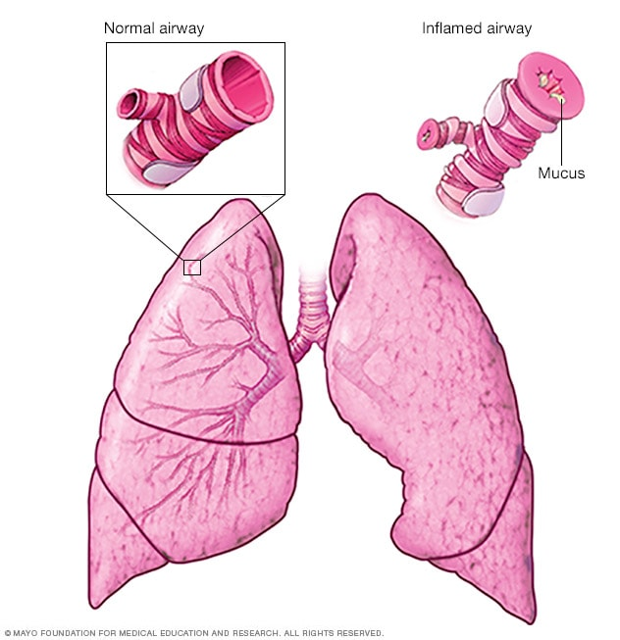

1. **CHRONIC OBSTRYCTIVE PULMONARY DISEASE:**With this lung condition, you can’t exhale the way you usually would, which causes trouble breathing.

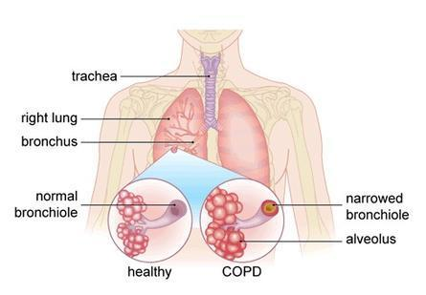

1. **CHRONIC BRONCHITIS:** This form of COPD brings a long-term wet cough.

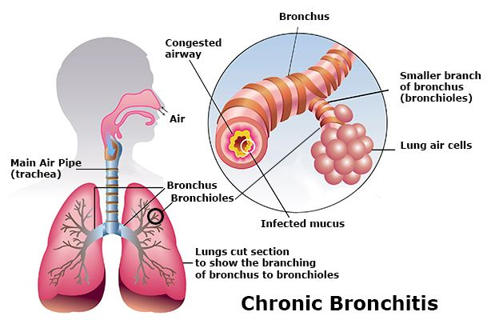

1. **EMPHYSEMA:** It is a chronic disorder in which alveolar walls damaged and they coalesce due to which respiratory surface area is decreased. The lungs show larger but fewer alveoli which are more fibrous and less elastic. One of the major causes of this is smoking of cigarette.

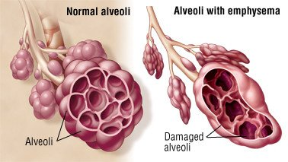

1. **ACUTE BRONCHITIS:** This sudden infection of your airways is usually caused by a virus.

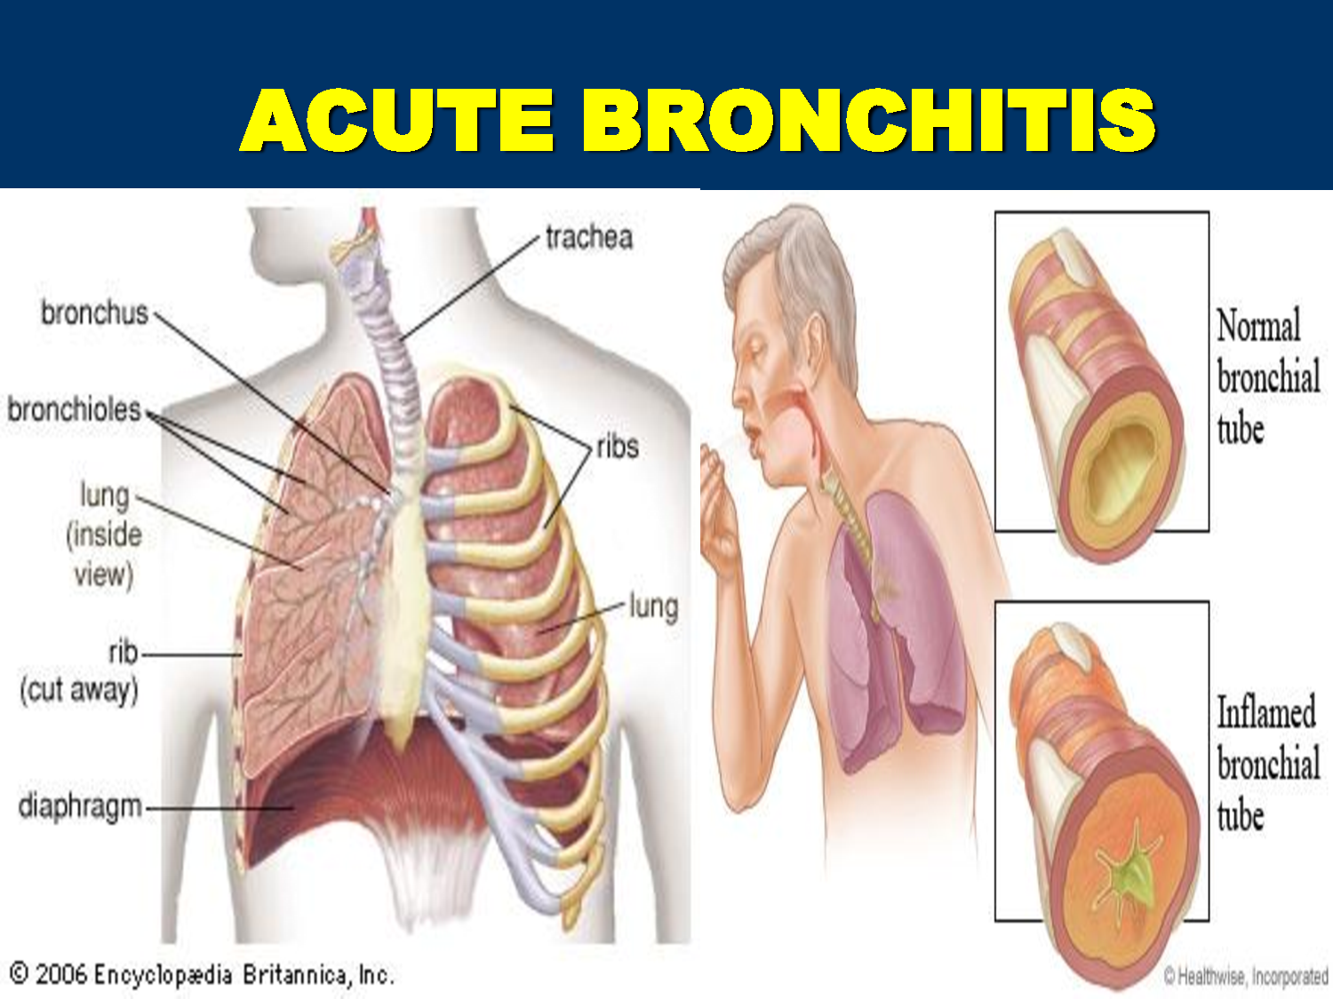

1. **CYSTIC FIBROSIS:** With this condition, you have trouble clearing mucus out of your bronchi. This leads to repeated lung infections.

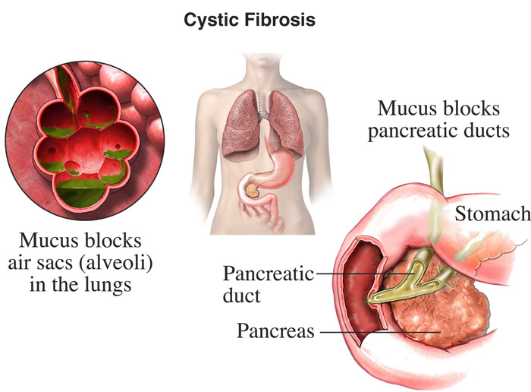

1. **PNEUMONIA:** It is an infection of lungs caused by bacteria such as *Streptococcus pneumonia* and also by certain viruses, fungi, protozoans and mycoplasmas. **SYMPTOMS:** Inflammation of lungs, accumulation of mucus in alveoli, and impaired exchange of gases, leading to death if untreated.

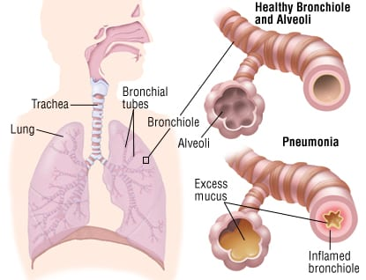

.

1. **PULMONARY FIBROSIS:** It is a lung disease that occurs when lung tissue becomes damaged and scared. This thickened, stiff tissue makes it more difficult for your lungs to work properly. As pulmonary fibrosis worsens, person becomes progressively shorter of breath. The lung damage caused by pulmonary fibrosis can't be repaired, but medications and therapies can sometimes help ease symptoms and improve quality of life. For some people, a lung transplant might be appropriate.

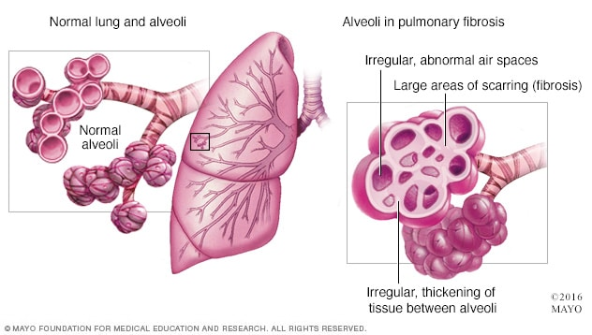

1. **LUNG CANCER:**

Cancer is a disease in which cells in the body grow out of control. When cancer starts in the lungs, it is called lung cancer. Lung cancer begins in the lungs and may spread to lymph nodes or other organs in the body, such as the brain. Cancer from other organs also may spread to the lungs. When cancer cells spread from one organ to another, they are called as metastases. Lung cancers usually are grouped into two main types called small cell and non-small cell. These types of lung cancer grow differently and are treated differently. Non-small cell lung cancer is more common than small cell lung cancer.

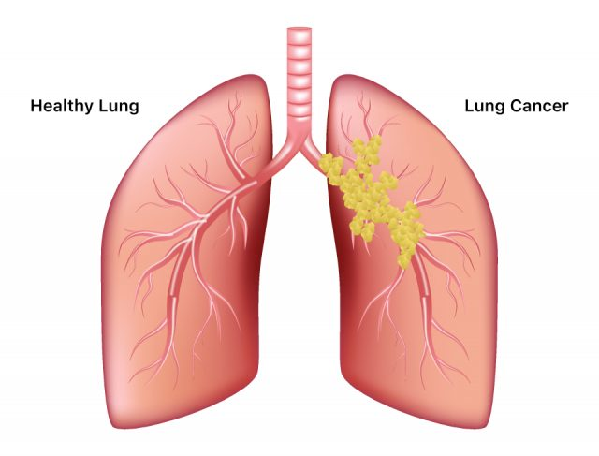

**TREATMENENTS**

**ASTHMA:** Prevention and long-term control are key to stopping asthma attacks before they start. Treatment usually involves learning to recognize your triggers, taking steps to avoid triggers and tracking your breathing to make sure your medications are keeping symptoms under control. In case of an asthma flare-up, you may need to use a quick-relief inhaler.

### **Medications**

The right medications for you depend on a number of things — your age, symptoms, asthma triggers and what works best to keep your asthma under control. Preventive, long-term control medications reduce the swelling (inflammation) in your airways that leads to symptoms. Quick-relief inhalers (bronchodilators) quickly open swollen airways that are limiting breathing. In some cases, allergy medications are necessary.

**Long-term asthma control medications,** generally taken daily, are the cornerstone of asthma treatment. These medications keep asthma under control on a day-to-day basis and make it less likely you'll have an asthma attack. Types of long-term control medications include:

1. **Inhaled corticosteroids.** These medications include fluticasone propionate (Flovent HFA, Flovent Diskus, Xhance), budesonide (Pulmicort Flexhaler, Pulmicort Respules, Rhinocort), ciclesonide (Alvesco), beclomethasone (Qvar Redihaler), mometasone (Asmanex HFA, Asmanex Twisthaler) and fluticasone furoate (Annuity Ellipta). You may need to use these medications for several days to weeks before they reach their maximum benefit. Unlike oral corticosteroids, inhaled corticosteroids have a relatively low risk of serious side effects.
2. **Leukotriene modifiers.** These oral medications — including montelukast (Singular), zafirlukast (Accolate) and zileuton (Zyflo) — help relieve asthma symptoms. Montelukast has been linked to psychological reactions, such as agitation, aggression, hallucinations, depression and suicidal thinking. Seek medical advice right away if you experience any of these reactions.
3. **Combination inhalers.** These medications — such as fluticasone-salmeterol (Advair HFA, Airduo Digihaler, others), budesonide-formoterol (Symbicort), formoterol-mometasone (Dulera) and fluticasone furoate-vilanterol (Breo Ellipta) — contain a long-acting beta agonist along with a corticosteroid.
4. **Theophylline.** Theophylline (Theo-24, Elixophyllin, Theochron) is a daily pill that helps keep the airways open by relaxing the muscles around the airways. It's not used as often as other asthma medications and requires regular blood tests.
5. **Quick-relief (rescue) medications** are used as needed for rapid, short-term symptom relief during an asthma attack. They may also be used before exercise if your doctor recommends it. Types of quick-relief medications include:
6. **Short-acting beta agonists.** These inhaled, quick-relief bronchodilators act within minutes to rapidly ease symptoms during an asthma attack. They include albuterol (ProAir HFA, Ventolin HFA, others) and levalbuterol (Xopenex, Xopenex HFA). Short-acting beta agonists can be taken using a portable, hand-held inhaler or a nebulizer, a machine that converts asthma medications to a fine mist. They're inhaled through a face mask or mouthpiece.
7. **Anticholinergic agents.** Like other bronchodilators, ipratropium (Atrovent HFA) and tiotropium (Spiriva, Spiriva Respimat) act quickly to immediately relax your airways, making it easier to breathe. They're mostly used for emphysema and chronic bronchitis, but can be used to treat asthma.
8. **Oral and intravenous corticosteroids.** These medications — which include prednisone (Prednisone Indenol, Rayo’s) and methylprednisolone (Medrol, Depo-Medrol, Solu-Medrol) — relieve airway inflammation caused by severe asthma. They can cause serious side effects when used long term, so these drugs are used only on a short-term basis to treat severe asthma symptoms. If you have an asthma flare-up, a quick-relief inhaler can ease your symptoms right away. But you shouldn't need to use your quick-relief inhaler very often if your long-term control medications are working properly. Keep a record of how many puffs you use each week. If you need to use your quick-relief inhaler more often than your doctor recommends, see your doctor. You probably need to adjust your long-term control medication.
9. **Allergy medications** may help if your asthma is triggered or worsened by allergies. These include.
10. **Allergy shots (immunotherapy).** Over time, allergy shots gradually reduce your immune system reaction to specific allergens. You generally receive shots once a week for a few months, then once a month for a period of three to five years.
11. **Biologics.** These medications — which include omalizumab (Xolair), mepolizumab (Nucala), dupilumab (Dupixent), erlizumabs and pembrolizumab (Fasenra) — are specifically for people who have severe asthma.

### **Bronchial thermoplasty**

This treatment is used for severe asthma that doesn't improve with inhaled corticosteroids or other long-term asthma medications. It isn't widely available nor right for everyone. During bronchial thermoplasty, your doctor heats the insides of the airways in the lungs with an electrode. The heat reduces the smooth muscle inside the airways. This limits the ability of the airways to tighten, making breathing easier and possibly reducing asthma attacks. The therapy is generally done over three outpatient visits.

**CHRONIC BRONCHITIS:**

1. **Medication** and lifestyle changes can lessen the symptoms of your chronic bronchitis and may slow or stop the disease from getting worse. Many people live with moderate symptoms for a long time, and breathe on their own without supplemental oxygen.  Your first step, if you smoke, is to quit. Your lungs will not fully recover, but the rate of decline will be much slower.
2. **Airway openers (**[**bronchodilators**](https://www.webmd.com/asthma/guide/asthma_inhalers_bronchodilators)**):** These drugs relax your air passages to make it easier to breathe and relieve your [bronchitis symptoms](https://www.webmd.com/lung/understanding-bronchitis-symptoms).
3. **Anti-inflammatory drugs:** [Steroids](https://www.webmd.com/a-to-z-guides/ss/slideshow-steroids-101) lessen the swelling that narrows your air passages.
4. **Oxygen therapy:** This is for serious cases, where your lungs are so damaged that [blood](https://www.webmd.com/heart/anatomy-picture-of-blood) oxygen levels are extremely low. You can inhale oxygen from a portable machine at home as needed.
5. **Specialized rehab program:** If you are often short of breath, rehab therapy can teach you ways manage your disease. For example, you might learn a better way to breathe while you [exercise](https://www.webmd.com/fitness-exercise/default.htm).
6. **Lung transplant:** A new lung or lungs may help you live longer.

**CHRONIC OBSTRUCTIVE PULMONARY DISEASE:**

The goal of therapy for chronic bronchitis is to relieve symptoms, prevent complications and slow the progression of the disease. Quitting smoking is also essential for patients with chronic bronchitis, since continuing to use tobacco will only further damage the lungs. Our Tobacco Education Center offers [classes](https://www.ucsfhealth.org/services/stop-smoking-classes) as well as individual consultations with doctors trained in treating tobacco addiction. We help smokers maximize the likelihood of success in their efforts to quit.

**Treatment may include:**

1. **Bronchodilator Medications** Inhaled as aerosol sprays or taken orally, bronchodilator medications may help to relieve symptoms of chronic bronchitis by relaxing and opening the air passages in the lungs.
2. **Steroids** Inhaled as an aerosol spray, steroids can help relieve symptoms of chronic bronchitis. Over time, however, inhaled steroids can cause side effects, such as weakened bones, high blood pressure, diabetes and cataracts. It is important to discuss these side effects with your doctor before using steroids.
3. **Antibiotics** may be used to help fight respiratory infections common in people with chronic bronchitis.
4. **Vaccines** Patients with chronic bronchitis should receive a flu shot annually and pneumonia shot every five to seven years to prevent infections.
5. **Oxygen Therapy** As a patient's disease progresses, they may find it increasingly difficult to breathe on their own and may require supplemental oxygen.

Oxygen comes in various forms and may be delivered with different devices, including those you can use at home.

1. **Surgery** Lung volume reduction surgery, during which small wedges of damaged lung tissue are removed, may be recommended for some patients with chronic bronchitis.
2. **Pulmonary Rehabilitation** An important part of chronic bronchitis treatment is pulmonary rehabilitation, which includes education, nutrition counseling, learning special breathing techniques, help with quitting smoking and starting an exercise regimen.
3. Because people with chronic bronchitis are often physically limited, they may avoid any kind of physical activity. However, regular physical activity can actually improve a patient's health and wellbeing.

**EMPHYSEMA**

Emphysema and COPD can't be cured, but treatments can help relieve symptoms and slow the progression of the disease.

### **Medications**

Depending upon the severity of your symptoms, your doctor might suggest:

1. **Bronchodilators.** These drugs can help relieve coughing, shortness of breath and breathing problems by relaxing constricted airways.
2. **Inhaled steroids.** Corticosteroid drugs inhaled as aerosol sprays reduce inflammation and may help relieve shortness of breath.
3. **Antibiotics.** If you have a bacterial infection, like acute bronchitis or pneumonia, antibiotics are appropriate.

### **Therapy**

1. **Pulmonary rehabilitation.** A pulmonary rehabilitation program can teach you breathing exercises and techniques that may help reduce your breathlessness and improve your ability to exercise.
2. **Nutrition therapy.** You'll also receive advice about proper nutrition. In the early stages of emphysema, many people need to lose weight, while people with late-stage emphysema often need to gain weight.
3. **Supplemental oxygen.** If you have severe emphysema with low blood oxygen levels, using oxygen regularly at home and when you exercise may provide some relief. Many people use oxygen 24 hours a day. It's usually administered via narrow tubing that fits into your nostrils.
4. **Surgery** Depending on the severity of your emphysema, your doctor may suggest one or more different types of surgery, including:
5. **Lung volume reduction surgery.** In this procedure, surgeons remove small wedges of damaged lung tissue. Removing the diseased tissue helps the remaining lung tissue expand and work more efficiently and helps improve breathing.
6. **Lung transplant.** Lung transplantation is an option if you have severe lung damage and other options have failed.

**ACUTE BRONCHITIS**

**Drug classes that may be used to treat chronic bronchitis include:**

Antibiotics to treat coughs, breathlessness, and mucus production caused by infections. Anti-inflammatory drugs, such as corticosteroids to reduce swelling and mucus output. Steroids can have many different types of side effects, including swelling in feet and hands, mood changes, increased appetite and weight gain, and more serious ones such as diabetes, higher risk of infections, osteoporosis, and cataracts.

Bronchodilators to keep muscles around the airways relaxed so that airway stay open. There are long-acting and short-acting bronchodilators. Short acting products are often called rescue drugs because they act quickly, but wear off in a couple of hours. Combination drugs that contain a mix of steroids and long-or short-acting bronchodilators.

**CYSTIC FIBROSIS:**

There is no cure for cystic fibrosis, but treatment can ease symptoms, reduce complications and improve quality of life. Close monitoring and early, aggressive intervention is recommended to slow the progression of CF, which can lead to a longer life. Managing cystic fibrosis is complex, so consider getting treatment at a center with a multispecialty team of doctors and medical professionals trained in CF to evaluate and treat your condition.

The goals of treatment include:

1. Preventing and controlling infections that occur in the lungs
2. Removing and loosening mucus from the lung
3. Treating and preventing intestinal blockage
4. Providing adequate nutrition

**PNEUMONIA:**

Treatment for pneumonia involves curing the infection and preventing complications. People who have community-acquired pneumonia usually can be treated at home with medication. Although most symptoms ease in a few days or weeks, the feeling of tiredness can persist for a month or more. Specific treatments depend on the type and severity of your pneumonia, your age and your overall health. The options include:

1. **Antibiotics:** These medicines are used to treat bacterial pneumonia. It may take time to identify the type of bacteria causing your pneumonia and to choose the best antibiotic to treat it.
2. **Cough medicine:** This medicine may be used to calm the cough so that person can rest. Because coughing helps loosen and move fluid from the lungs, it's a good idea not to eliminate the cough completely. If a person needs to try a cough suppressant, he must use the lowest dose that helps in rest.
3. **Fever reducers/pain relievers:** These are taken for fever and discomfort. These include drugs such as aspirin, ibuprofen and acetaminophen.

**PULMONARY FIBROSIS:**

1. **Medication:** Two medications — pirfenidone and nintedanib may slow down lung scarring. These medications can help preserve lung function.
2. **Oxygen therapy:** Giving body extra oxygen helps you breathe more easily. It may also increase your energy and strength.
3. **Pulmonary rehabilitation:** Staying active in this special exercise program may improve how much a person can do everyday tasks or activities.
4. **Lung transplant:** A lung transplant replaces one or both diseased lungs with a healthy lung from a donor. It offers the potential to improve health and quality of life. A lung transplant is major surgery, and not everyone is a candidate.

**LUNG CANCER:**

## Surgery:

Surgery is part of the treatment for early-stage lung cancers. The type of surgery depends on the size and location of the tumor in the lung, the extent of the cancer, the general health of the patient and other factors. Many surgeries are done with a long incision in the side of the chest, known as a thoracotomy. Some early-stage tumors may be treated with video-assisted thoracic surgery (VATS), which uses several small incisions and special long surgical tools.

**Types of surgery include:**

1. **Segmental or wedge resection:** Removal of only a small part of the lung
2. **Lobectomy:** Removal of an entire lobe of the lung
3. **Pneumonectomy:** Removal of an entire lung
4. **Sleeve resection:** Removal of a piece of bronchus, after which the lung is reattached to the remaining part of the bronchus

## Radiation Therapy:

Radiation therapy is the use of high-energy radiation to kill cancer cells and to shrink tumors. Radiation may also be used with chemotherapy to treat lung cancer.

The following techniques are used to deliver radiation therapy:

**External radiation:** A treatment that precisely sends high levels of radiation directly to the cancer cells. Radiation is used to kill cancer cells and to shrink tumors, special shields may be used to protect the tissue surrounding the treatment area. Radiation treatments are painless and usually last a few minutes.

## Chemotherapy:

Whereas surgery and radiation treatment are focused at only one area of the body, chemotherapy goes throughout the body to search for tumor cells. Chemotherapy is given through an IV infusion, in most cases. chemotherapy works by interfering with the cancer cells’ ability to grow or reproduce. Different groups of drugs work in different ways to fight cancer cells. Chemotherapy may be given before other treatments, after other treatments or alone for lung cancer.

## Targeted Therapy:

Targeted therapy is like chemotherapy in that it goes throughout the body in search of tumor cells. These are drugs that target specific parts of cancer cells or nearby cells that help them grow. So far, these drugs have only been found to be useful for some non-small cell lung cancers. Medications with other specific targets, such as erlotinib and cetuximab, may also be useful.

**REFERENCES**

1. Goldman L, et al., eds. Chronic obstructive pulmonary disease. In: Goldman-Cecil Medicine. 25th ed. Philadelphia, Pa.: Saunders Elsevier; 2016. http://www.clinicalkey.com. Accessed Jan. 12, 2017.
2. AskMayoExpert. Chronic obstructive pulmonary disease. Rochester, Minn.: Mayo Foundation for Medical Education and Research; 2016.
3. Ferguson GT, et al. Management of stable chronic obstructive pulmonary disease. http://www.uptodate.com/home. Accessed Jan. 11, 2017.
4. FIRS The Global Impact of Respiratory Disease Available from:<https://www.who.int/gard/publications/The_Global_Impact_of_Respiratory_Disease.pdf> (accessed 7.5.2020)
5. Enaud R, Prevel R, Ciarlo E, Beaufils F, Wieërs G, Guery B, Delhaes L. [The gut-lung axis in health and respiratory diseases: a place for inter-organ and inter-kingdom crosstalks.](https://www.frontiersin.org/articles/10.3389/fcimb.2020.00009/full) Frontiers in cellular and infection microbiology. 2020 Feb 19; 10:9 Available from: <https://www.frontiersin.org/articles/10.3389/fcimb.2020.00009/full> (accessed 8.5.2021)